Sum-Meet
Use Case Specification

Submitted to:

Asst. Prof. Ma. Rowena C. Solamo
Faculty Member
Department of Computer Science
College of Engineering
University of the Philippines, Diliman

Submitted by:
Batula, Bryce Spencer
Bayuga, Michael John
Yap, John Theodore

In partial fulfillment of academic requirements
for the course
CS 191 Software Engineering I
of the
1st Semester, AY 2015-2016
Unique Reference:
The documents are stored in https://github.com/trackertech568/CS191-Batula-Bayuga-Yap.
[File Reference in GitHub, preferably link.]

Document Purpose:
To show the flow of events of a use-case from its diagram.

Target Audience:
Meeting organizers.

Revision Control

History Revision:
Revision Date | Person Responsible | Version  Number | Modification
09/18/15 | Batula, Bryce  Bayuga, Michael  Yap, John Theodore | 1.0 | Initial Document; Version number should match the one found in the footer.

Use-Case Name: 5.0 Send New Schedule

Description: If the meeting organizer changes some information about the meeting, the system will send a new notification to the attendee. The attendee should reply again if he/she can still go to the meeting or not.

Preconditions: The meeting organizer should have edited some details about the meeting.

Flow of Events:
Scenario Name | Description
Scenario 1 (Basic Flow)  Meeting organizer changes the details about the meeting. Either it’s date, time or place. | 1. Meeting organizer edited information about the meeting.  2. System will receive the changes.  3. The system will relay the changes to the attendee.

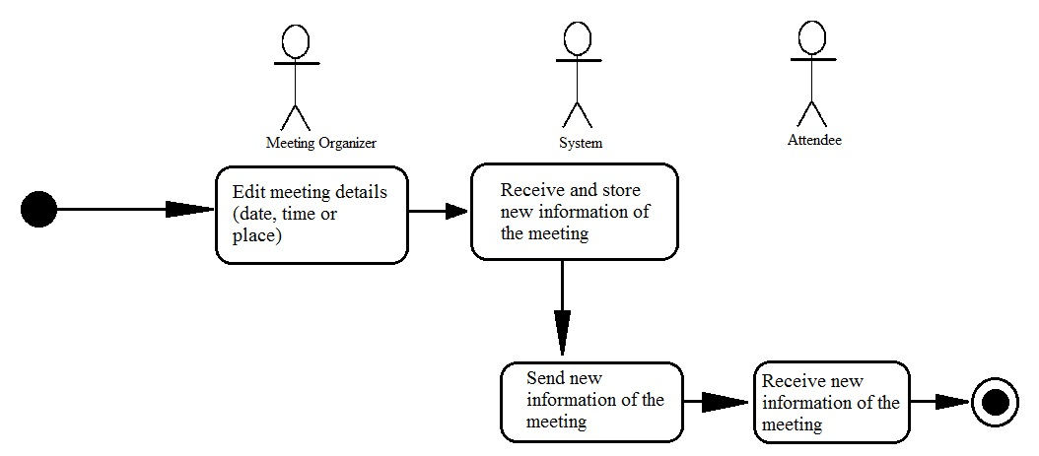
Activity Diagram of the Flow of Events:

Postcondition: Attendee must reply if they can still attend the meeting or not.

Relationships: NONE

Special Requirements: NONE

